Spearman rank correlation: NZDUSD and USDCAD
Method 02 / daily log returns / Alpari D1 full available history

Study setup
Logical pair: NZDUSD , USDCAD
Broker symbols: NZDUSD_i , USDCAD_i
Snapshot: 2026-11-03_majors_alpari_D1
Timeframe: D1
Matched return window: 1999-01-05 to 2026-11-02 (UTC bar dates)
Matched return count n: 7190
Dropped unfinished last bar dated 2026-11-03 UTC after a tick-volume check against the prior complete day.
Complete matched rows (CSV): NZDUSD-USDCAD_Spearman_D1.csv
Complete matched rows (HTML table): NZDUSD-USDCAD_Spearman_D1_data.html

Method carried forward
Spearman rho is Pearson correlation on the ranks of matched daily log returns of close, ln(close_t / close_t-1), in the broker quote direction. Ties use average ranks. Quotes are not inverted. rho is symmetric under swap of the two symbols. rho = 0 means no consistent rank-order link in this sample; it does not mean no link of any kind. The score is not a cause, not a lead, and not a trading signal. Daily rows are not independent draws, so the two-sided p-value and approximate Fisher interval are reported and treated as secondary to rho. Same-sample Pearson r is shown only as a side check; a large rho minus r gap can flag outliers or a non-straight link.

Results
Spearman rho: -0.535570
Two-sided p-value: 0
Approximate 95% Fisher interval: [-0.551853, -0.518878]
Same-sample Pearson r: -0.587831
rho minus r: 0.052261

Conclusion
Over 7190 matched daily log-return rows for NZDUSD and USDCAD (broker quote directions unchanged), Spearman rho is -0.5356 (negative, moderate rank-order association in this sample). Approximate 95% Fisher interval: [-0.5519, -0.5189]. Same-sample Pearson r is -0.5878 (rho minus r = 0.0523). Two-sided p under the usual independent-ranks model is 0; that model does not match linked daily FX returns, so treat p as secondary. This does not establish cause, lead-lag, or a lasting trading rule.

Charts
Daily closes

Daily log returns
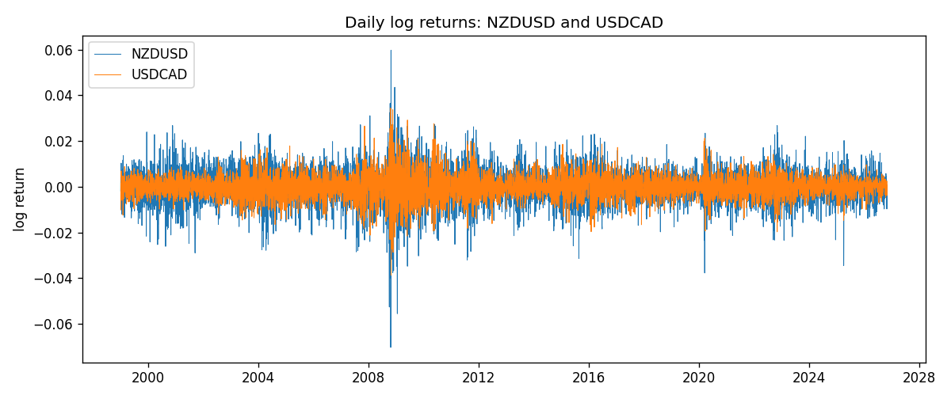
Log-return scatter
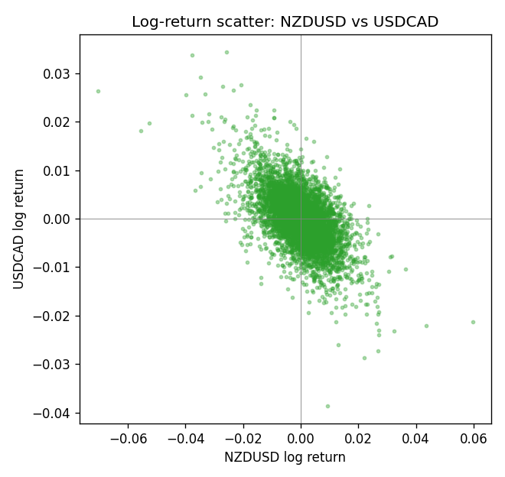
Rank-rank scatter
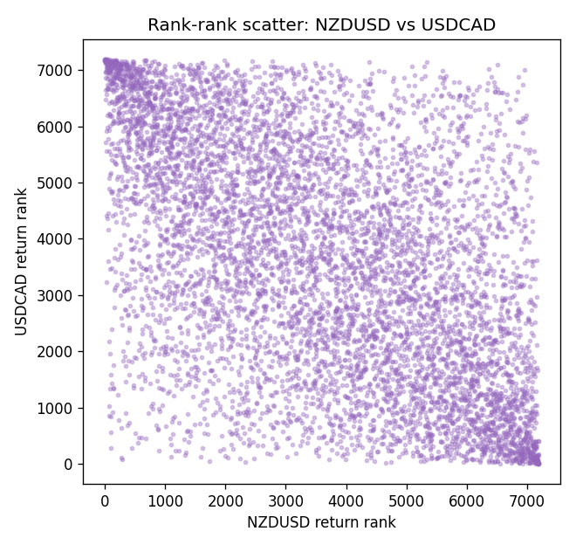

Data report
Every matched row that entered Spearman rho is stored in the sibling CSV named NZDUSD-USDCAD_Spearman_D1.csv. That file is the complete data archive for redrawing charts. Embedding all rows as a Word table is impractical at this length; the Word file holds the column list, column summaries, and the first and last 15 matched rows.
Columns: time, NZDUSD_open, USDCAD_open, NZDUSD_high, USDCAD_high, NZDUSD_low, USDCAD_low, NZDUSD_close, USDCAD_close, NZDUSD_tick_volume, USDCAD_tick_volume, NZDUSD_spread, USDCAD_spread, NZDUSD_real_volume, USDCAD_real_volume, NZDUSD_log_return, USDCAD_log_return
Column summaries (matched calculation rows)
column | count | mean | std | min | 25% | 50% | 75% | max
NZDUSD_open | 7190 | 0.6563919 | 0.10821436 | 0.3913 | 0.5912925 | 0.6684 | 0.7249075 | 0.88218
USDCAD_open | 7190 | 1.2668559 | 0.16897553 | 0.9168 | 1.118445 | 1.298545 | 1.37213 | 1.6183
NZDUSD_high | 7190 | 0.66030697 | 0.10871111 | 0.3961 | 0.5947025 | 0.67202 | 0.72936 | 0.88421
USDCAD_high | 7190 | 1.2717549 | 0.16892987 | 0.9336 | 1.122975 | 1.30394 | 1.37655 | 1.619
NZDUSD_low | 7190 | 0.65270307 | 0.10781082 | 0.3897 | 0.5880525 | 0.664185 | 0.720965 | 0.87988
USDCAD_low | 7190 | 1.2623003 | 0.16901312 | 0.9056 | 1.114125 | 1.293585 | 1.36785 | 1.6102
NZDUSD_close | 7190 | 0.65646372 | 0.10821182 | 0.3907 | 0.5915625 | 0.66842 | 0.725015 | 0.8822
USDCAD_close | 7190 | 1.266877 | 0.16895077 | 0.916 | 1.118165 | 1.298615 | 1.372425 | 1.6137
NZDUSD_tick_volume | 7190 | 68672.777 | 123109.57 | 16 | 5561.25 | 33864.5 | 58508 | 1127682
USDCAD_tick_volume | 7190 | 80995.8 | 147287.89 | 37 | 5534 | 40938 | 71622.5 | 1410818
NZDUSD_spread | 7190 | 30.299444 | 25.655426 | 0 | 9 | 17 | 50 | 80
USDCAD_spread | 7190 | 23.448679 | 18.267866 | 0 | 9 | 17 | 40 | 60
NZDUSD_real_volume | 7190 | 1.6692087e+10 | 8.4955308e+10 | 0 | 0 | 0 | 0 | 2.705649e+12
USDCAD_real_volume | 7190 | 1.8371592e+10 | 9.6675129e+10 | 0 | 0 | 0 | 0 | 2.5751613e+12
NZDUSD_log_return | 7190 | 6.02e-06 | 0.00764513 | -0.07027433 | -0.00425619 | 0.00022347 | 0.00457637 | 0.05966839
USDCAD_log_return | 7190 | -9.38e-06 | 0.0051433 | -0.03859748 | -0.00283202 | 5.381e-05 | 0.00272817 | 0.03436319
First 15 matched rows (selected columns)
time | NZDUSD_close | USDCAD_close | NZDUSD_log_return | USDCAD_log_return | NZDUSD_tick_volume | USDCAD_tick_volume
1999-01-05 | 0.5372 | 1.5123 | -0.0018597736 | -0.010131666 | 748 | 1345
1999-01-06 | 0.5383 | 1.5118 | 0.0020455609 | -0.0003306769 | 823 | 1803
1999-01-07 | 0.5417 | 1.5141 | 0.0062963171 | 0.0015202092 | 878 | 1568
1999-01-08 | 0.5414 | 1.511 | -0.00055396548 | -0.0020495197 | 668 | 914
1999-01-11 | 0.547 | 1.5057 | 0.010290425 | -0.0035137769 | 681 | 953
1999-01-12 | 0.5441 | 1.5157 | -0.0053157489 | 0.0066194721 | 793 | 1507
1999-01-13 | 0.5387 | 1.5226 | -0.0099742238 | 0.0045420214 | 1050 | 2141
1999-01-14 | 0.5386 | 1.5332 | -0.00018564931 | 0.0069376546 | 1137 | 1816
1999-01-15 | 0.5382 | 1.5245 | -0.00074294208 | -0.0056905671 | 1124 | 1897
1999-01-18 | 0.5372 | 1.526 | -0.0018597736 | 0.00098344542 | 1022 | 1091
1999-01-19 | 0.5382 | 1.5302 | 0.0018597736 | 0.002748513 | 1389 | 1634
1999-01-20 | 0.5404 | 1.5211 | 0.0040793678 | -0.0059646885 | 1678 | 1499
1999-01-21 | 0.5426 | 1.5146 | 0.0040627941 | -0.0042823796 | 1599 | 2007
1999-01-22 | 0.5361 | 1.5184 | -0.012051689 | 0.0025057712 | 1328 | 1713
1999-01-25 | 0.5342 | 1.5197 | -0.0035504102 | 0.00085579808 | 1035 | 1471
Last 15 matched rows (selected columns)
time | NZDUSD_close | USDCAD_close | NZDUSD_log_return | USDCAD_log_return | NZDUSD_tick_volume | USDCAD_tick_volume
2026-10-13 | 0.56127 | 1.4214 | 0.0047326165 | -0.0046395653 | 27958 | 50947
2026-10-14 | 0.55918 | 1.42356 | -0.0037306483 | 0.0015184751 | 37319 | 56126
2026-10-15 | 0.56185 | 1.41843 | 0.0047634855 | -0.0036101503 | 43714 | 63096
2026-10-16 | 0.56509 | 1.41357 | 0.0057501001 | -0.0034322068 | 35806 | 54908
2026-10-19 | 0.56616 | 1.41091 | 0.0018917133 | -0.0018835331 | 32069 | 52155
2026-10-20 | 0.56827 | 1.40569 | 0.0037199341 | -0.0037066008 | 34470 | 54450
2026-10-21 | 0.57003 | 1.4045 | 0.0030923331 | -0.00084691787 | 30020 | 51369
2026-10-22 | 0.56815 | 1.40081 | -0.0033035227 | -0.0026307268 | 39159 | 58806
2026-10-23 | 0.56991 | 1.40085 | 0.0030929853 | 2.85545e-05 | 33693 | 50387
2026-10-26 | 0.56826 | 1.40093 | -0.0028993932 | 5.7106554e-05 | 30716 | 49601
2026-10-27 | 0.56811 | 1.40449 | -0.00026399852 | 0.0025379458 | 32660 | 49541
2026-10-28 | 0.56261 | 1.39911 | -0.0097283914 | -0.0038379274 | 42740 | 56077
2026-10-29 | 0.56296 | 1.39895 | 0.00062190714 | -0.00011436495 | 40247 | 59551
2026-10-30 | 0.56307 | 1.39751 | 0.00019537668 | -0.0010298736 | 39305 | 59373
2026-11-02 | 0.56161 | 1.39837 | -0.0025962955 | 0.00061519094 | 35347 | 53578

